AGENDA - Little Hoole Parish Council  Members of the Council are summoned to the Parish Council Meeting to be held on  Mon 13th July 2026 at 7:00pm  The Residents’ Lounge, Old Mill Court, Liverpool Old Road, Walmer Bridge, PR4 5QU  Paul Cafferkey, Clerk & Responsible Financial Officer | 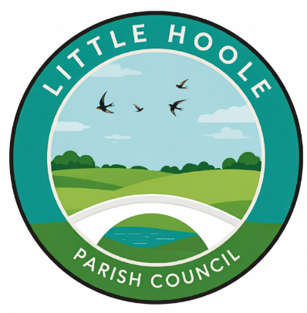
- Apologies for absence
- To agree the Minutes of the last Parish Council Meeting held on the 8th June 2026.
- To receive declarations of interest.
- Matters arising from the minutes of last meeting.
  - Public Time: to invite and listen to issues raised by members of the public.
  - To consider the following Planning Applications:
    - 07/2026/00405/CLD. 39 Tillage Close Walmer Bridge PR4 5BZ. Single storey rear extension
    - 07/2026/00248/FUL. Land At Low Barn Pine Avenue Little Hoole PR4 5LB. Following demolition of existing dwelling & associated outbuildings, erection of 1no. replacement detached dwelling (self-build/custom build), 1no. detached garage, and associated infrastructure.

  - To approve the following transactions in the bank for June 2026.
  - Payments approved by email or pre-approved and retrospectively noted:
    - Payment due to Cllr Dryden for work done on 5th, 6th 13th, 15th, 27th 30th June. 14 hrs @ £25, + £1 misc. Total £351. Grass cutting, weed clearing pruning, planting, strimming, watering, re The Wave Path, The Green, Community Garden, Flower Barrels

  - Payments for approval:
    - Clerk’s claim for June 2026
    - Additional £100 (excl VAT) to Andrew Burgess (wood carver) for extra work, 4x log seats for Little Hoole Primary School, plus creation of log seat on park from tree stump.
  - To approve Finance Report as at 30 June 2026
  - Proposal for the Parish Council to fund regular mowing of “The Green”.
  - Proposal for the Parish Council to fund weeding and hedge cutting at entrance to Dob Lane Recreation Park.
  - To approve revised Grants Policy, including provision to offer grants for environmental and bio diversity projects.
  - Update re Summer Activities Programme
  - Update re diversion of FP0707050 in relation to planning application 07/2024/0768/FUL
  - Update: re the replacement of the two bus shelters at the junction of Liverpool Old Road and Liverpool New Road (Star Garage).
  - Update re Pond at Old Mill Court-re Lillies & Duck Sign
  - Update re Memory Bench.
  - Update re Summer Planting.
  - Change of date for September 2026 Parish Council meeting.
  - Information and Updates.
  - Correspondence – None
  - To agree the date, time, and venue for the Sept 2026 meeting (NB no meeting in August).
Members of the public are welcome to attend meetings to raise any relevant matters. Alternatively, if you cannot attend the meeting but wish to raise a matter or ask a question, this can be done on your behalf by contacting the Parish Clerk (Paul Cafferkey) via email clerk@littlehoole-pc.gov.uk or mobile phone 07966267186.
Visit the Little Hoole Parish Council Website https://www.littlehoole-pc.gov.uk or scan the following QR code.


Prepared and approved by Paul Cafferkey, Clerk – Little Hoole Parish Council,
8th July 2026

